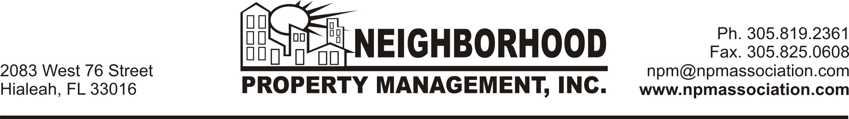

BE ADVISED: TENANTS ARE NOT PERMITTED TO HAVE ANY PETS IN THEIR UNITS DURING THEIR RENTAL CONTRACT. No Exceptions!!!!

I certify that I do not have any pets and I won’t have any pets during my rental at
West Palm Villas Condo

- I certify that should I fail to comply with the Pets policy at West Palm Villas Condominium will be subject to Eviction by the Association.

- I certify and understand that all of the above and that any breach to this understanding will result in immediate Eviction of ALL residents of the above mentioned unit.

NOTE:
The Approval for Rental is granted only to the applicant(s) which information was received on the original application. Everyone must complete the screening process prior to taking residence at said location. If you fail to comply with this request, the APPROVAL LETTER will be automatic voided, and will be grounds for eviction.

______________________ ____________________

Applicant Print Name Date
______________________ _________________________
Applicant 2: Print Name Date

_______________________ _________________________
Witness Date

________________________

West Palm Villas Condominium
C/O Neighborhood Property Management, Inc.

